Government College University, Lahore

**Data Structures and Algorithms**

**BSCS Semester-IV**

**LAB -2**

# Total Marks: 10 Time: 90 Minutes

**Q1:** You are developing a **Library Management System** that allows librarians to **add books** to the system. However, if a book is mistakenly added, the librarian should be able to **undo the last added book**. To achieve this, implement a **stack-based approach** where each added book is stored in a **stack**, and the **undo feature** removes the most recently added book

#### ****1. Implement Stack Class:**** Include push (), pop (), isEmpty(), top(), and displayStack() function

#### ****2. Implement Book Addition and Undo Functionality****

* **Push** book titles onto the stack when a book is added.
* **Pop** the last added book when undoing.
* **Display the current book stack**.

#### ****3. Provide a Menu for User Interaction****

* 1. **Add a new book** (Push to Stack).
  2. **Undo last added book** (Pop from Stack).
  3. **Display all books** (Show Stack Content).
  4. **Exit**.

**Expected output**:

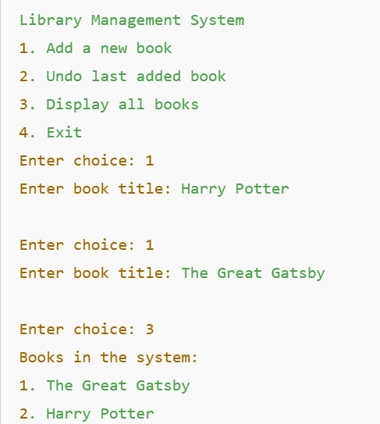

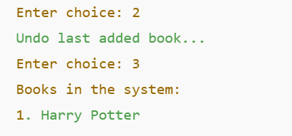

**Q2:** Develop a C++ program that **accepts a postfix expression, prints it out**, and then **evaluates its value** using a **stack-based approach.** Compile and run the program using the following input:

6 2 3 + - 3 8 2 / + * 2 $ 3 +.